IS487 Emerging Topics in IS

Week 02 – Lab: Flutter Widgets & Layouts

Lab Objectives
By the end of this lab, students will be able to: - Understand the concept of “Everything is a Widget” - Use common Flutter widgets such as Scaffold, AppBar, Container, Row, and Column - Differentiate between Stateless and Stateful widgets - Apply layout concepts including alignment, padding, margin, and Expanded widgets

What You Will Build
A simple Flutter application that displays: - An AppBar with a title and icon - A centered layout containing text and an image - A Row and Column layout demonstrating alignment - Proper spacing using padding, margin, and Expanded widgets

Step 1: Create a New Flutter Project
- Open VS Code.
- Create a new Flutter project and name it lab02.

Step 2: Update AppBar
- Open lib/main.dart.
- Change the app title to: IS487 – Widgets & Layouts
- Locate the AppBar and modify as follows:
  - Add a leading icon using Icons.menu
  - Add one action icon using Icons.info
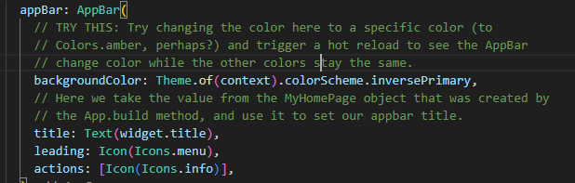

Step 3: Change the text
- Replace the counter and the existing textwith :
  - A Text widget displaying: Everything is a Widget
  - A second Text widget displaying your name

Step 4: Use Container and Styling
- Wrap one of the Text widgets inside a Container.
- Add the following properties to the Container:
  - Padding: 16
  - Margin: 10
  - Background color
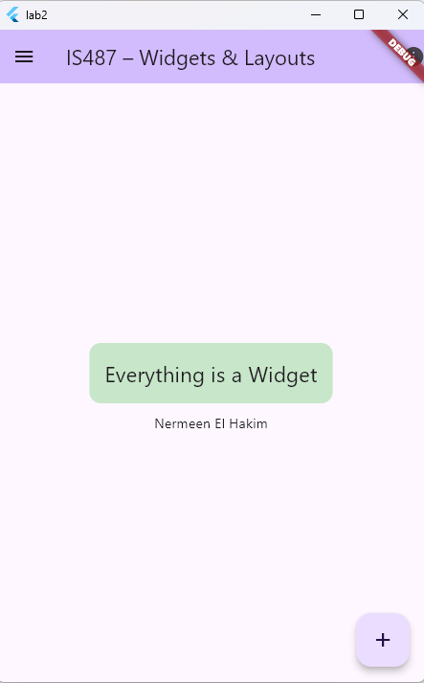
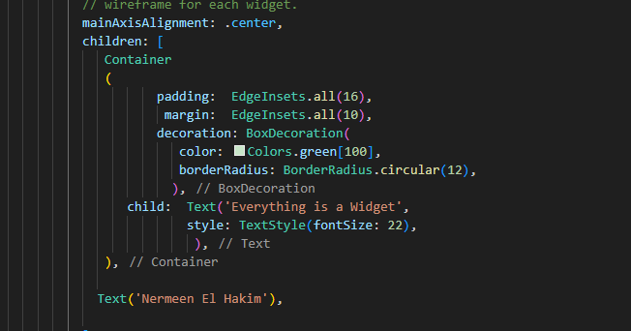
  - Rounded border radius

Step 5: Add a Row with Expanded Widgets
- Below the Column, add a Row widget.
- Inside the Row, add three Container widgets.
- Wrap each container with Expanded.
- Assign different flex values (1, 2, 1).
- Give each container a different background color and a height of 60.

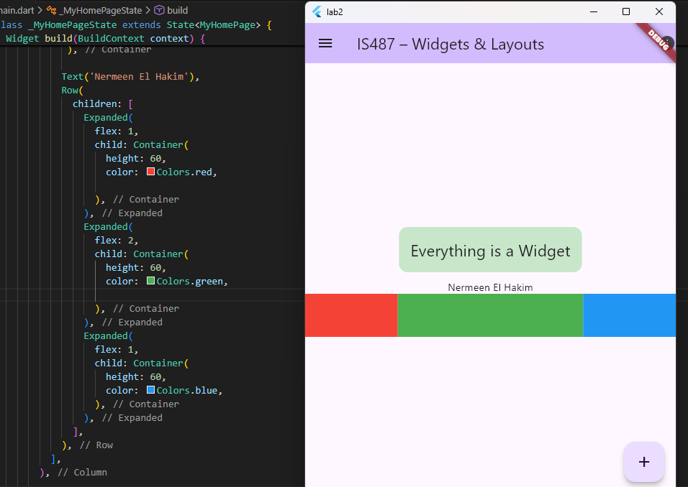

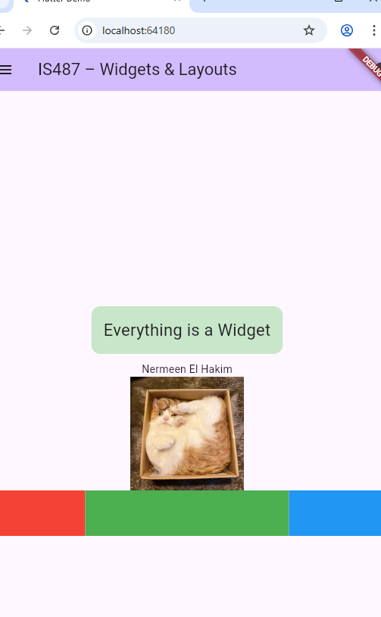
Step 6: Add an Image Asset
- Create a folder named assets/images in your project.
- Add a square image to this folder.
- Update pubspec.yaml to include the assets folder.
- Run the following command in the terminal flutter pub get. You must run it every time you update the file.
- Display the image using the Image.asset() widget.

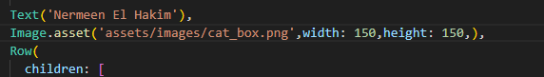
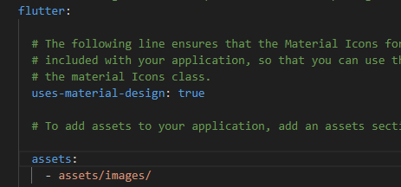
Figure 2-main.dart
Figure 1-pubspec.yaml

Note: YAML is extremely strict about spaces (indentations).
Key rules:
- flutter: has no spaces before it
- assets: is 2 spaces under flutter
- - assets/images/ is 4 spaces under assets
- If it appears in red then you have the spaces wrong.

Step 7: Handle Screen Overflow
- Wrap the main Column widget with SingleChildScrollView.
- Run the app and verify there is no overflow error.
- Note: don’t forget to close the brackets at the end.

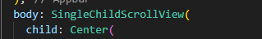

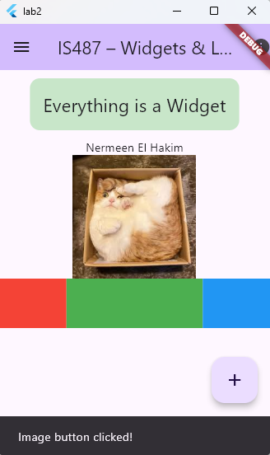
Step 8: Message with snack bar
- Modify the code of the FloatingActionButton to show a message using SnackBar

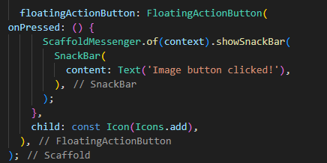

At home
Convert the screen containing the Image into a StatefulWidget

Lab Task (Submission)
Students must submit on moodle: - Screenshot of the running app showing all widgets -

